Mobile Network - Backhaul

🔗 What Is Backhaul?
# Source: AI Source: Provided by: [Data Path: Persons Table -> ID Column: 1, Name_En Column: Motasem Essam] -> From: [ChatGPT] on [1/23/2026]
In a telecommunications network, backhaul refers to the connection between the core network (internet, phone switching center, etc.) and the access network (cell towers, Wi-Fi points, etc.).
In simple terms:
📡 The backhaul is the "bridge" that carries voice, data, and video from cell towers to the internet or the main telecom network — and back.

Backhaul Image
# Source: Table Source: Provided by: [Data Path: Persons Table -> ID Column: 1, Name_En Column: Motasem Essam] From: [Data Path: Miscellaneous Folder -> Miscellaneous Database -> Miscellaneous Table -> ID: 32] on [1/23/2026]
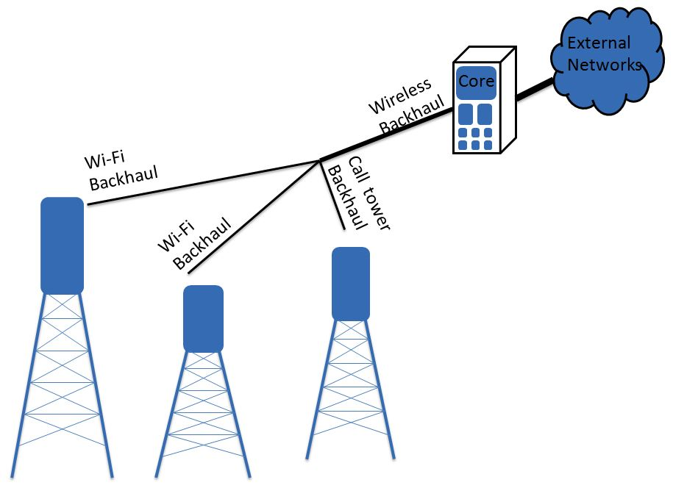

📡 Where Does Backhaul Fit?
# Source: AI Source: Provided by: [Data Path: Persons Table -> ID Column: 1, Name_En Column: Motasem Essam] -> From: [ChatGPT] on [1/23/2026]
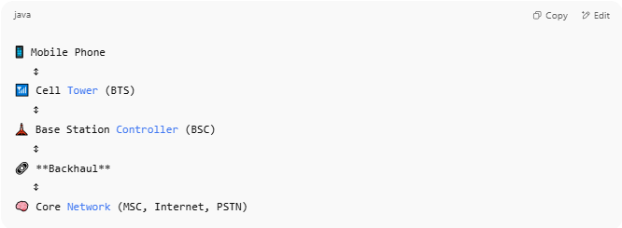

📱 Mobile Phone
↕
📶 Cell Tower (BTS)
↕
🗼 Base Station Controller (BSC)
↕
🔗 **Backhaul**
↕
🧠 Core Network (MSC, Internet, PSTN)

- Access network: Phones → BTS → BSC
- ✅ Backhaul: BSC → Core Network

🔧 Types of Backhaul Technologies:
# Source: AI Source: Provided by: [Data Path: Persons Table -> ID Column: 1, Name_En Column: Motasem Essam] -> From: [ChatGPT] on [1/23/2026]
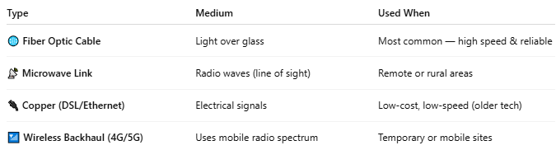

Type | Medium | Used When
🌐 Fiber Optic Cable | Light over glass | Most common — high speed & reliable
📡 Microwave Link | Radio waves (line of sight) | Remote or rural areas
🔌 Copper (DSL/Ethernet) | Electrical signals | Low-cost, low-speed (older tech)
📶 Wireless Backhaul (4G/5G) | Uses mobile radio spectrum | Temporary or mobile sites

🧩 Backhaul in Different Networks:
# Source: AI Source: Provided by: [Data Path: Persons Table -> ID Column: 1, Name_En Column: Motasem Essam] -> From: [ChatGPT] on [1/23/2026]
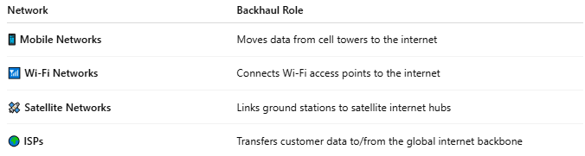

Network | Backhaul Role
📱 Mobile Networks | Moves data from cell towers to the internet
📶 Wi-Fi Networks | Connects Wi-Fi access points to the internet
🛰️ Satellite Networks | Links ground stations to satellite internet hubs
🌍 ISPs | Transfers customer data to/from the global internet backbone

🚦 Why Backhaul Is Important:
# Source: AI Source: Provided by: [Data Path: Persons Table -> ID Column: 1, Name_En Column: Motasem Essam] -> From: [ChatGPT] on [1/23/2026]
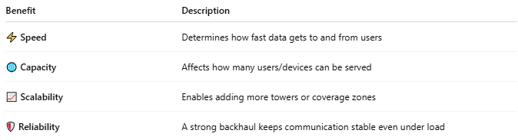

Benefit | Description
⚡ Speed | Determines how fast data gets to and from users
🌐 Capacity | Affects how many users/devices can be served
📈 Scalability | Enables adding more towers or coverage zones
🛡️ Reliability | A strong backhaul keeps communication stable even under load

📖 Summary:
# Source: AI Source: Provided by: [Data Path: Persons Table -> ID Column: 1, Name_En Column: Motasem Essam] -> From: [ChatGPT] on [1/23/2026]
Backhaul is the critical link that connects local access points like cell towers or routers to the core telecom or internet network. It’s essential for delivering fast, reliable service in mobile, broadband, and enterprise networks.

